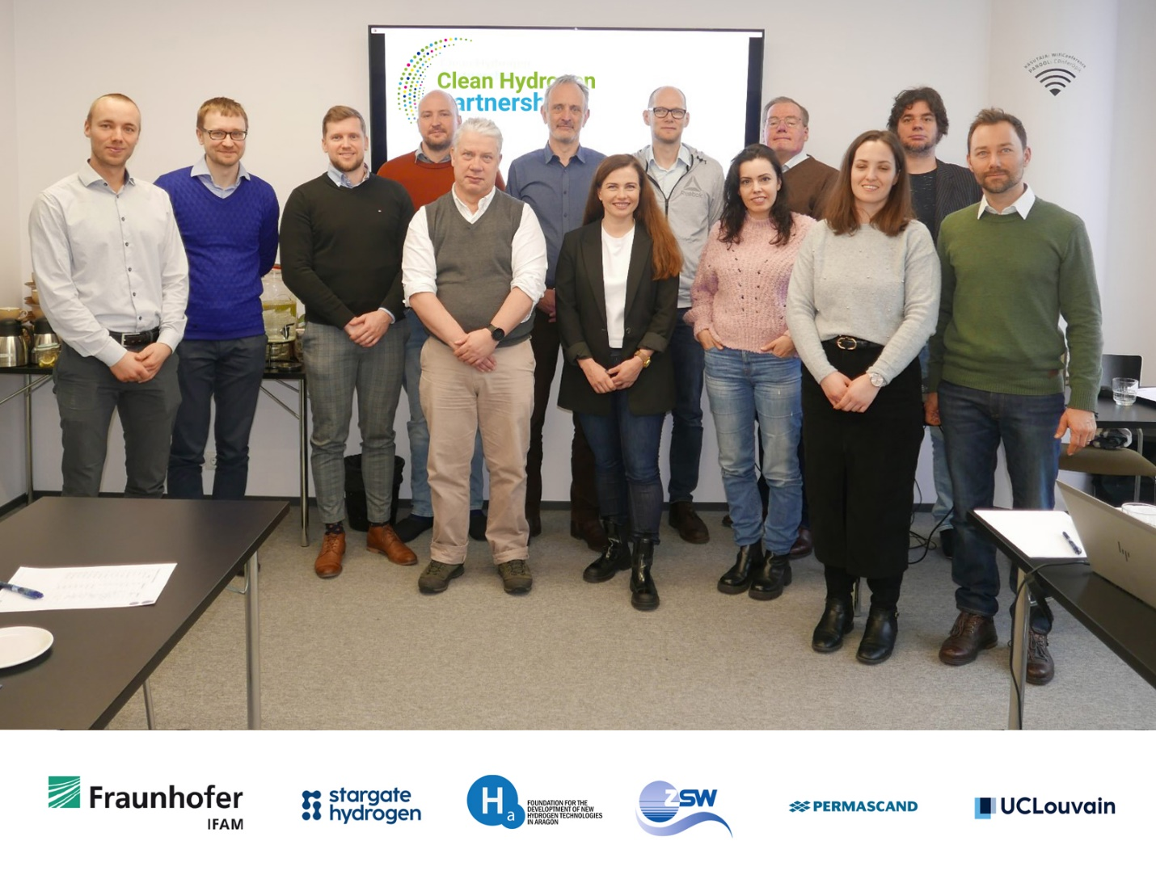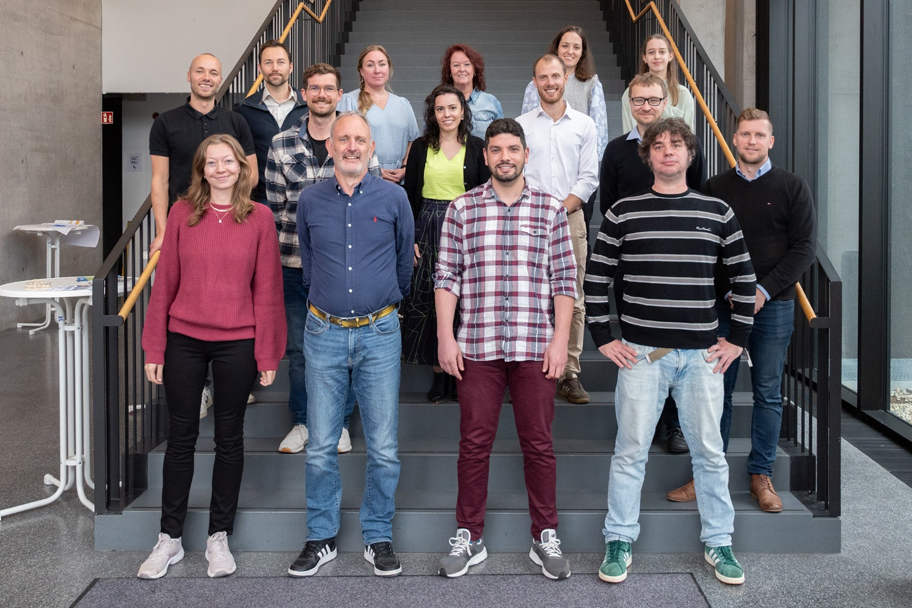

2-year retrospective: the ENDURE Consortium on its Way to Intensification and Durability Assessment of Alkaline Electrolysis

The Green Hydrogen Partnership funded research and innovation project ENDURE looks back on two years of technological developments, and forward to the final year.
The ENDURE project – funded under the call HORIZON-JTI-CLEANH2-2023-01-03 Advances in alkaline electrolysis technology, Grant Agreement GA: 101137925 – started on the 1st of January 2024. Entering its third and final year, it now focuses on concluding its Porous Transport Electrode (PTE) electrode development campaign, as well as the corresponding stack-level upscaling activities.
The goal of the ENDURE project is to design an electrolyser stack that operates at very high current densities and electrolyte flow rates thanks to the innovative technological components developed by the consortium partners. The ENDURE consortium brings together six partners:
- Stargate Hydrogen Solutions OÜ, leader of cell and stack development and management;
- Fraunhofer IFAM, leader of electrode development and scale-up;
- Center for Solar Energy and Hydrogen Research (ZSW), leader of testing and validation;
- Aragon Hydrogen Foundation, leader of establishing methods and baseline and testing of the 10 kW stack;
- Elicron, contributes to electrode development;
- Université Catholique de Louvain (UCLouvain), leader of dissemination and exploitation, contributes to electrode development through Computational Fluid Dynamics (CFD).
In the project, a particular emphasis is placed on durability, with electrode improvements focused on decreasing the degradation rate of alkaline electrolysis cells, with design and material innovations on stack level and with the development of accelerated testing procedures. These developments are currently being realised in the various prototype stacks of the consortium members.
One of the important achievements of the project to-date has been the establishment and refinement of multiple electrode development loops within the consortium. The first such loop consists of the fabrication of flow-engineered monolithic electrodes at IFAM, their characterisation by micro-computed X-ray tomography at UCLouvain, and the Computational Fluid Dynamics (CFD) modeling of electrolyte flow through these complex structures, using the tomography images to generate electrode meshing, followed by electrochemical testing at IFAM and UCLouvain. This first loop has produced several generations of electrodes, among which the most promising candidates consist in bi-layer Ni foams, with and without screen-printed Ni patterning. These electrodes showed exceptional performance, associated with the lowest ohmic resistance reported in the literature, pointing at optimized bubble removal.
A second development loop involves IFAM, focusing on the development of a Ni-Mo based coating for the Hydrogen Evolution Reaction (HER) and a Ni-Mo nitride-based coatings for the Oxygen Evolution Reaction (OER), and Elicron, who is responsible for upscaling of the developed electrodes. The developed electrodes have revealed excellent performance coupled with long-term durability. Scale-up activities are ongoing.
The third development loop involves the interplay between electrode fabrication and testing. The porous electrode structures characterized by UCLouvain on cell-level have been fabricated on 100 cm² scale by Fraunhofer IFAM and assembled into short stacks by ZSW. The stacks, which involved various PTE configurations at the same time, were tested under industrially-relevant conditions. Two stacks with different candidate structures have been tested by ZSW, with the results demonstrating that the effect of porous transport layers in alkaline electrode stacks is indeed very significant. So far in the project, Ni-based PTEs have been tested, but in the final year of ENDURE, electrodes coated with the most promising catalyst coatings will also be integrated with the help of Elicron.
In addition to the development loops described above, a “baseline” 10kW stack – the backbone of stack development within ENDURE, built by Stargate Hydrogen and tested at FHa – was shipped to FHa, installed and integrated to the local Balance-of-Plant (BoP) and durability-tested according to a pre-defined test protocol. The ENDURE test protocols were shared with the EU Joint Research Centre (JRC), whose feedback helped refine the conditions and disseminate the ENDURE testing procedures. Key insights from the baseline stack study include a successful stack testing campaign with protocols developed within ENDURE, assessment of the operating window of the test bench and cell-by-cell EIS analysis. No permanent degradation was observed after 573h of operation and 45 ON-OFF cycles.
A modelling CFD campaign is also running between Stargate and UCLouvain, taking its input from micro-scale (explicit) PTE modelling, as well as cell- and stack-scale multiphysics modelling, combining electrochemistry with fluid dynamics. This notably led to a dual-phase description of gas-electrolyte dynamics in our stacks, and led towards key design improvements in some stack components.
Rainer Küngas, the Chief Technology Officer of Stargate Hydrogen, comments: “The progress that we have achieved in the project in the first two years has been nothing short of remarkable. As project coordinator, Stargate is pleased to work together with such academic and industrial partners. As the project enters its final year, we look forward to a lot of exciting results as we combine the innovations developed in different parts of the project – many remarkable on their own – into final prototypes. By the time the ENDURE project concludes, we wish to demonstrate beyond doubt that the “old and boring” alkaline electrolysis technology still has substantial improvement potential left.”

Coordinator
- Stargate Hydrogen Solutions OÜ is an alkaline electrolyser OEM, focusing on the commercialisation of its novel electrode and stack technologies for the production of green hydrogen, with engineering support to accelerate hydrogen projects. Stargate’s innovation lies in novel ceramics-based electrode materials that bring high efficiency at low cost.
Partners
- For many years, Fraunhofer IFAM has been involved in numerous R & D projects in the innovative field of H₂ production (AMORPHEL, Green-H2, AEL3D, ELYntegration). Two key points are considered in the development of active catalysts: Material composition ("alloy design") and electrode topography and geometry.
- The Centre for Solar Energy and Hydrogen Research Baden-Württemberg" (ZSW), based in Southern Germany, was founded in 1988. The foundation's purpose is to transfer already existing knowledge from fundamental research in the fields of renewable energy and rational energy conversion to market-ready, application-based technology such as electrolysis technology to be used by industries located in the state.
- Aragon Hydrogen Foundation is a private non-for-profit organization promoted by the Regional Government of Aragon, Spain, 20 years ago. Its team of +40 experienced and young professionals performs R&D&I and consultancy projects in the cooperation with regional, national and European companies.
- Elicron is an independent technology-driven manufacturer of electrochemical solutions based on proprietary catalytic coatings for clean tech applications. With a customer-centric focus, the company has supplied electrodes, electrochemical cells and aftermarket services to a variety of sectors for more than 50 years.
- Building on almost 600 years of experience, UCLouvain is today a multisite university in Belgium at the forefront of innovation and excellence in education and research in all existing disciplines. Research and development is one of UCLouvain’s main activities with 22 research institutes, research centers, and technology platforms.

Start
- 01/01/2024
Duration
- 36 months
Budget
- € 2 495 480
Funding entity
- Clean Hydrogen Partnership

Funded by the Clean Hydrogen Partnership and its members
